## Product Requirement Document

As a big city, Beijing has many bakery brands, giving users plenty of room for choice. However, when people buy, they may be dazzled by too many choices and difficult to make a decision. I hope to use this website as an aggregation platform which selects the four most representative and popular bakeries in Beijing ( Holiland, Paris Baguette, Breadtalk, Auspicious Phoenix ), and compare their differences, highlighting their personal style, main products and geographic location of each bakery shop. At the same time, the user comments of each brand will be presented on the page as a reference of choice. What’s more, due to the frequent emergence of new products in bakery, it is difficult for users to know the taste of each bread in time. In order to avoid buying unappetizing bread, this platform will sort the tastes of bread, and users can find their own appetite only by searching. For bread, you can click the link on this website to enter the corresponding page and place an order directly.

|  |  |
| --- | --- |
| TARGET USERS | USER NEEDS |
| white-collar workers | They are busy at work and do not have time to research which bread is delicious, hoping to have a simple and time-saving way to buy bread. |
| Students | They like to try new things, but they are worried that the new bread they tasted is unpalatable, and they need an aggregation platform to help them make choices. |
| Housewife and Elderly | They hope to choose carefully, buy the most cost-effective and delicious bread, and also hope to find a convenient bakery near home. |

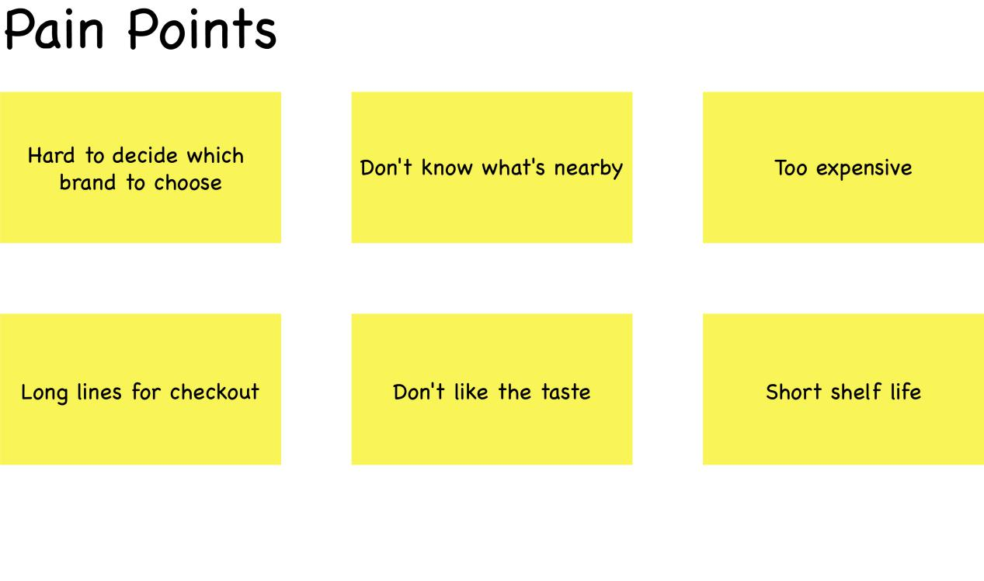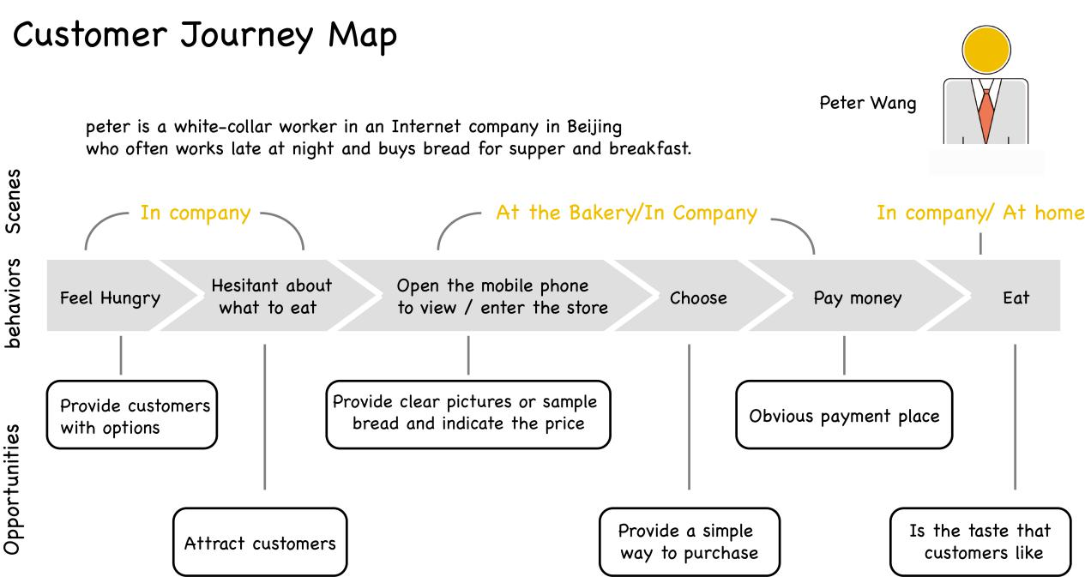

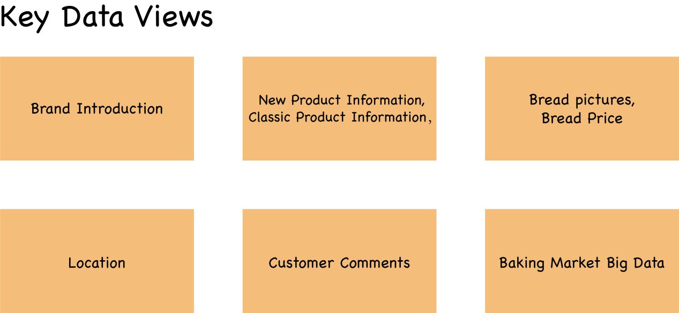Entity Relationship Diagram

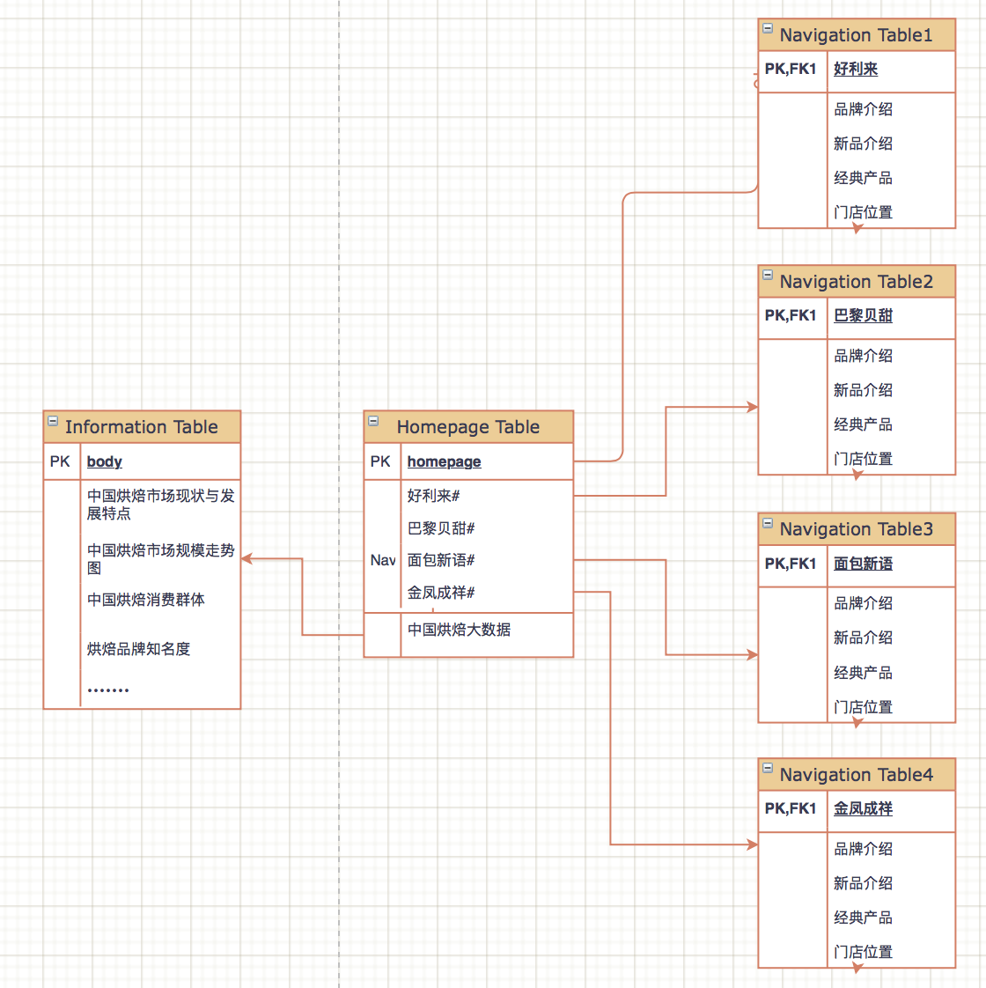

Dataflow Diagram

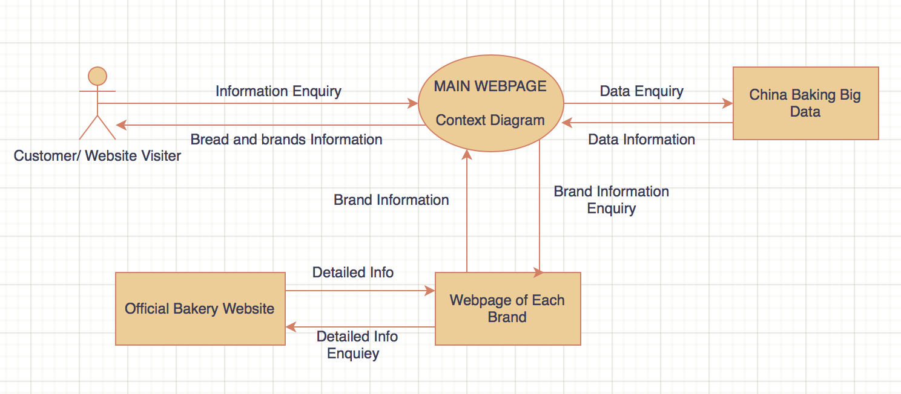Google Search

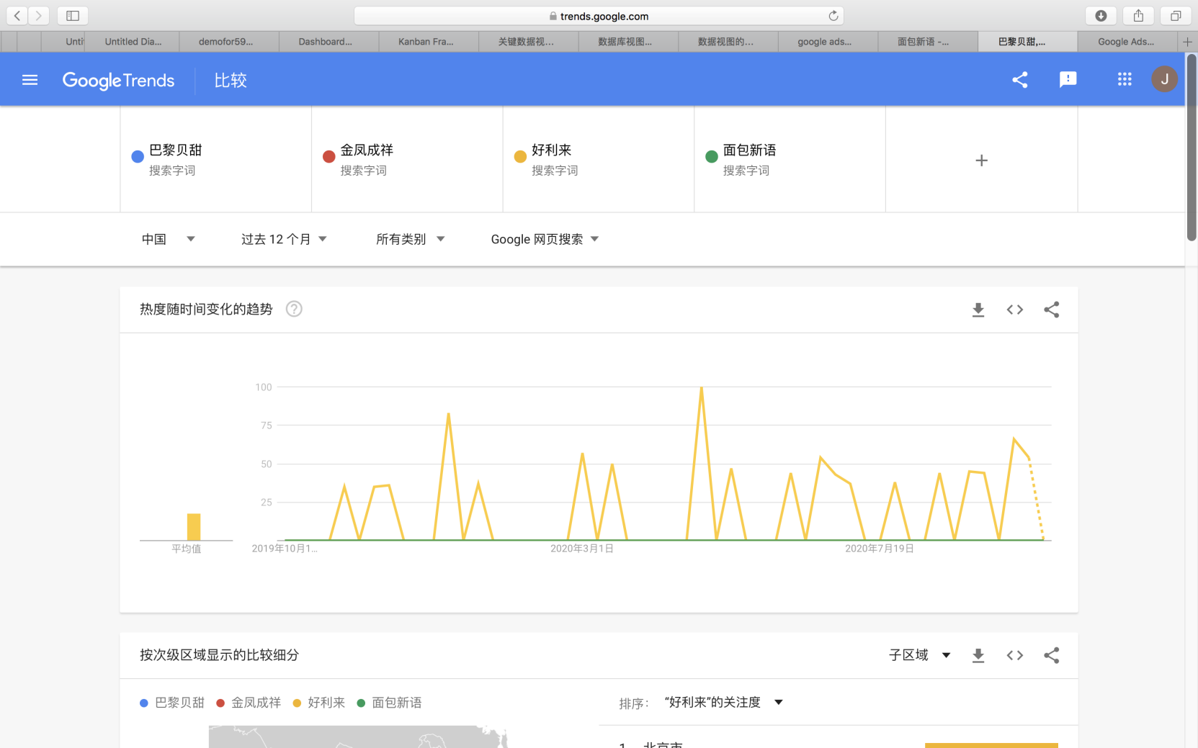

It can be seen that the search index of Holiland far exceeds that of other brands.